**Digital Logic Design**

**SEMESTER 2**

**LAB PROJECT PROPOSAL**



|  |  |
| --- | --- |
| ***Name of Students*** | ***Registration Number*** |
| **Muhammad Haris Irfan** | **FA18-BCE-090** |
|  |  |
| **Sana Elahi** | **FA18-BCE-054** |

**Submitted to:**

**Sir Imran Saeed Lodhi**

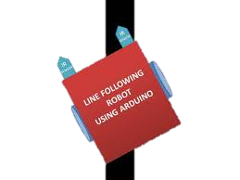

**What is a Line Following Robot?**

Line following robot is designed and programmed using Arduino to detect bright light using sensors which then drive the motor according to their output. It will be a robot that will basically follow the path determined by the user, the path maybe as simple as a straight or a curved line or it may be as complex as a 90 degree turn.

The line follower robot built in this project is divided in to 4 blocks. The following image shows the block diagram for line follower robot.

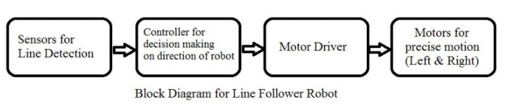

**Components Required:**

* 1pcs L298N motor driver.
* 1pcs ARDUINO MEGA2560 Controller Board
* 5pcs line tracking module.
* 4pcs motor.
* 4pcs wheels.
* 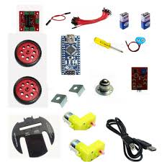Power Supply.
* 1pcs Robot Chassis.
* Connecting Wires.
* Sensor Shield or Bread Board.
* HC-06 Bluetooth Module (Optional)

**Circuit diagram**

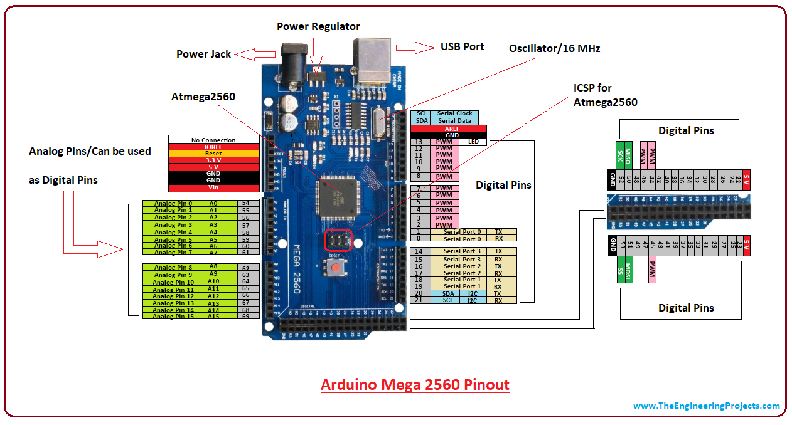

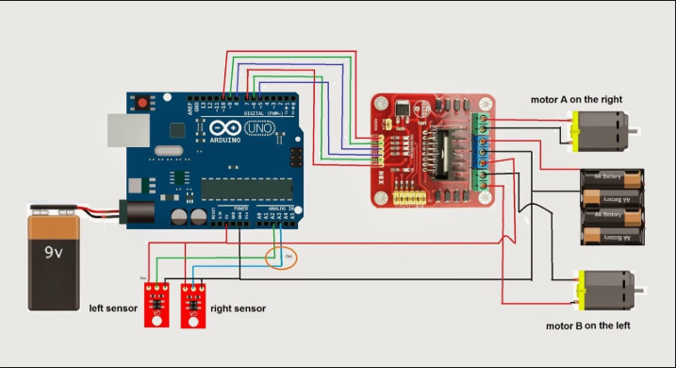**Circuit will be similar, but we will use Arduino MEGA 2560 and L298N Motor Driver Instead**

**Working Principle:**

Working of a line follower is very interesting as the robot senses the black line using the sensor and then sends the signal to Arduino which then drives it along the indicated path.

***The detailed working is explained here:***

We need sensors to detect the line. For line detection logic, we will use two IR Sensors, which will consist of IR LED and Photodiode. They will be placed in a reflective way i.e. side – by – side so that whenever they will come in to proximity of a reflective surface, the light emitted by IR LED will be detected by Photo diode.

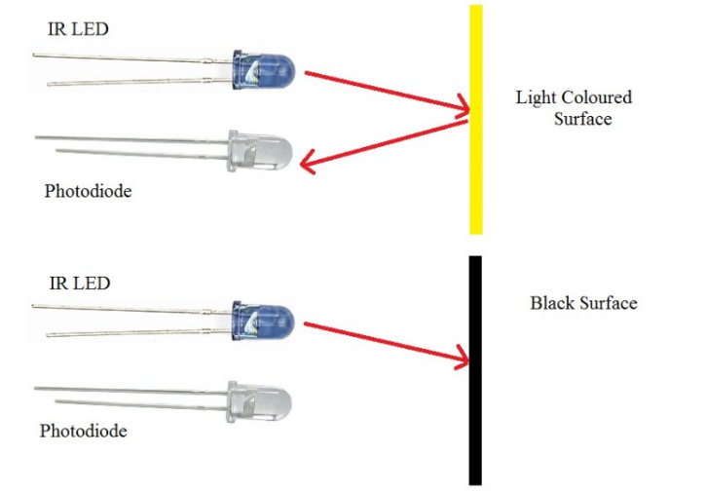The following image shows the working of a typical IR Sensor (IR LED – Photodiode pair) in front of a light colored surface and a black surface. As the reflectance of the light colored surface is high, the infrared light emitted by IR LED will be maximum reflected and will be detected by the Photodiode. In case of black surface, which has a low reflectance, the light gets completely absorbed by the black surface and doesn’t reach the photodiode.

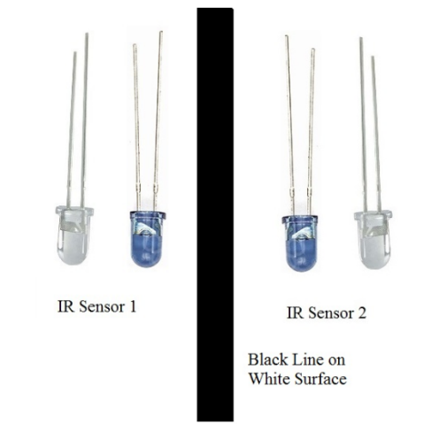Using the same principle, we will setup the IR Sensors on the Line Follower Robot such that the two IR Sensors are on the either side of the black line on the floor.

When the robot moves forward, both the sensors wait for the line to be detected. For example, if the IR Sensor 1 in the above image detects the black line, it means that there is a right curve (or turn) ahead

Arduino MEGA detects this change and sends signal to motor driver accordingly. In order to turn right, the motor on the right side of the robot is slowed down using PWM (Pulse Width Modulation), while the motor on the left side is run at normal speed.

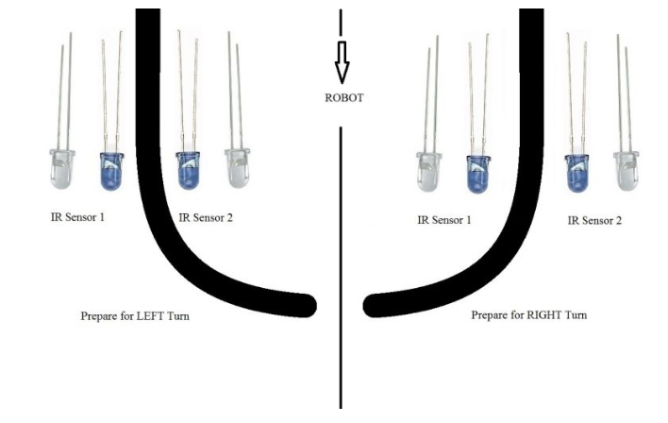 Similarly, when the IR Sensor 2 detects the black line first, it means that there is a left curve ahead and the robot has to turn left. For the robot to turn left, the motor on the left side of the robot is slowed down (or can be stopped completely or can be rotated in opposite direction) and the motor on the right side is run at normal speed.

Arduino MEGA continuously monitors the data from both the sensors and turns the robot as per the line detected by them.

**Line following Robot- An advancement of technology!**

The line following Robot is basically an advanced automated mobile operator which is being successfully used in many industrial and public fields to aid the work burden as it requires no human operating and can perform repetitive tasks following its assigned trajectory path with supervision, thus making manual work easier for humans in this era of rapid, demanding and progressive lifestyle.

**Request:** We hope that our proposal is approved so that we can begin with the actual project as soon as possible.

THANK YOU!